***Activity 1: (bubble)***

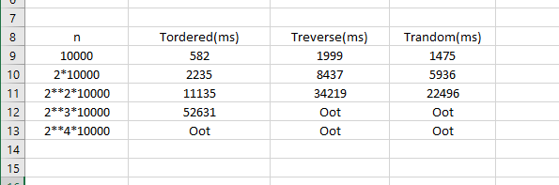

Intel® Core™ i7-4790 CPU @ 3.60 GHz, 8 GB DDR3

In the sorted one the vector is already sorted so the Bubble algorithm takes less time. Then in the random one some are well allocated and others no but it make the algorithm to expend less time ordered every element of the vector, so if we receive the vector at reserve order is normal that takes much more time than in the 2 cases before.

***Activity 2: (selection)***

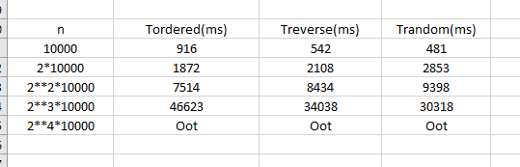

***Activity 3: (insertion)***

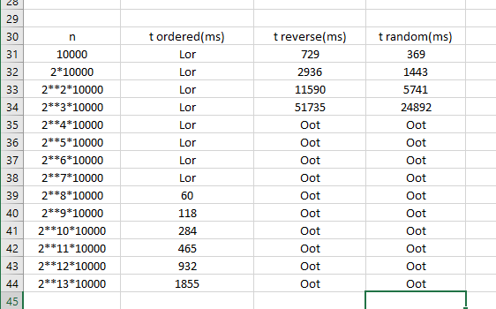

***Activity 4: (Quicksort)***

